December 1, 2022
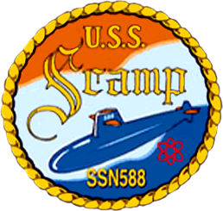
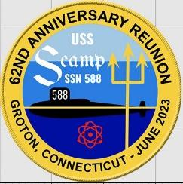

Ahoy Scampers
Hoping everyone had a wonderful Thanksgiving. It is official now that our 62nd Reunion will be held in Groton Connecticut and will be June 12th through the 16th. The Hotel we will be at is the Groton Inn and Suites, and the rates are $104 per night. We have a block of rooms (25) set aside for us. Reservation may be made by calling 1 (860)-445-9784.
Mentioning you’d like to reserve as part of the USS Scamp Reunion room block for Monday, June 12, 2023, for 4 nights, and would guarantee and pay with their own credit card. The rates are a substantial discount off typical rates for this week; $104.00 per room for single or double occupancy, plus 15% CT hotel tax. More than 2 occupants in a room would be $15.00 extra per guest. I have allocated 14 Rooms with Two Queen Beds, 3 Standard King rooms, and 8 Deluxe Suite King rooms. If you need more, let me know. This block of rooms is available to book up to 30 DAYS prior to June 12
Your Committee and I are still hard at work setting up tours, which include a bus tour around the area to visit Gillette Castle, Fort Griswold, and Mystic Sea port. We also have scheduled a tour of the Submarine Museum and the USS Nautilus. We are setting up contacts and working on getting a tour of the lower base and with luck it will include a visit to one of the new fast attacks. Also working on a trip to the Casino. This may be a small group, but we will have a 9-passenger van to use if we do not get a big response. We are very interested in your input as to things to do and what you would like to see. Please feel free to respond with any ideas and if you would like to get involved.
We will also be having the Silent Auction (if you wish to donate something please contact Rick Lannen at scampshipmate.588@gmail.com, the cribbage tournament ($10 entry) and an ACEY DEUCEY tournament ($10 entry fee). I am in contact with the Groton Sub Vets club, and they would love to have us over for lunch on Tuesday June 13th. We are still in negotiation about trip prices, but there will be a fee of 50 dollars per person, as it was the last reunion. This will cover the hospitality room, welcome gift and package. As Tony Armagno (treasurer) and Rick Lannen (Secretary) and myself continue to iron out more details we will keep everyone informed of progress. We will be sending out signup sheets and an agenda to allow you to plan your week. We would like to plan two social events, one Tuesday afternoon for Luncheon at the Groton Sub Vets and Thursday night, buffet dinner provided, to conduct our business meeting.
Also, we will once again have the Hospitality Room available with all the drinks and snacks that we are accustomed to with a few surprises. Thanks to Dean Cosentino for Hosting the room and getting everything ready. Rod Stark has also been set up to provide guest speakers and to provide all videos and photos for this event. Please check all web sites and face book groups as we will be posting updates to all.

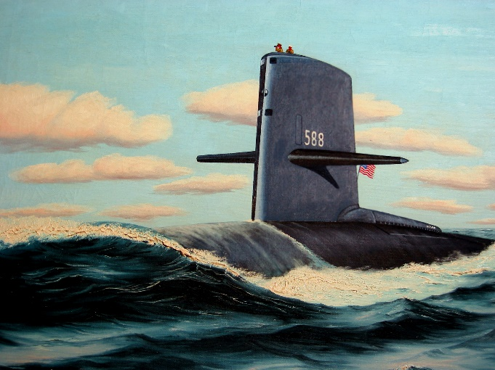
Facebook groups are Scamp Alumni and USS Scamp (588)
WEB SITE https://uss-scamp.net/
Please know we have established a Gmail account Scampshipmates.588@gmail. Com. We are currently loading all emails we have, and this will be easy to transfer in the future.
Special Thanks to Rich Erler for developing the patch to commemorate this event.
Once the plan of the week is established, prices are finalized I will be sending out the signup sheets.
The following is a list of personnel that have indicated to me thru E mail that they will be attending.
Tony Armagno, Robert Brand, Vince Britton, John Collis, Dean Cosentino, William Crutchfield David Fischer, Ron Jarrett, Ray Keele, Rick Lannen, Pete Limon, Greg Mowbray, Leonard Robbins, Harvey Sellers, Rod Stark, Bill Stover, James Tucker, and Jim Wilson.

